Lab Report Template Ⅰ
  - For ME336 Spring 2024
#Group 1(Replace this with your group number)
Zhang San 12345678 | Zhang San 12345678 | Zhang San 12345678
Zhang San 12345678 | Zhang San 12345678 | Zhang San 12345678
(Replace above with your own name and student ID)
Asst. Prof., Department of Mechanical & Energy Engineering, Southern University of Science and Technology, Shenzhen, China 518055

Lab part
In this section of the lab report, it is important to accurately document the experimental results following the order outlined in the lab tutorial. Please note that taking screenshots of the experimental code results to get the result picture. Although the majority of the code is provided for direct execution, it is necessary to perform the process on your personal device to ensure accuracy and consistency in the results.

Image acquisition
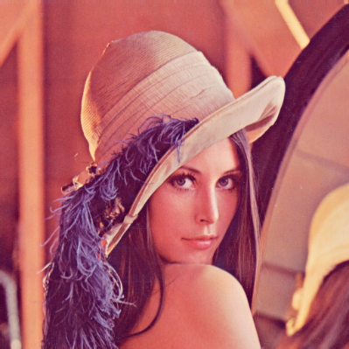
Fig1: Image captured by camera (Replace this with your own picture and renamed the fig title)

Image pre-processing

Noise reduction
[Copy the result jpg/png file here]

Image correction
[Copy the result jpg/png file here]

Image enhancement
[Copy the result jpg/png file here]

Image segmentation
[Copy the result jpg/png file here]

Resizing and cropping
[Copy the result jpg/png file here]

Feature detection and extraction
[Copy the result jpg/png file here]

Image analysis and interpretation
[Copy the result jpg/png file here]

Operational efficiency
[Copy the result jpg/png file here]

Hardware kits setting
[Copy the assembly result jpg/png file here]

Pose Estimation

Camera calibration
[Copy the result jpg/png file here, show your camera parameters]

Visual Object Tracking
[Copy the result jpg/png file here]

Machine Learning Algorithm

Linear Regression
[Copy the result jpg/png file here]

Support Vector Machine
[Copy the result jpg/png file here]

Multilayer Perceptron
[Copy the result jpg/png file here]

Assignment part
In this section of the laboratory experiment, it is necessary to integrate the various function codes developed in the previous phases and write new code as per the job's specifications to fulfil the given requirements of the task. This part of the experiment requires not only the successful execution of the code and obtaining results but also designing the experiment and analysing the outcomes. It is crucial to carefully plan and execute the experiment to ensure accurate and reliable results. Therefore, attention should be given to both the technical aspects of the code and the experimental design to achieve the desired objectives of the experiment.

Dataset

Test 1(Replace this with method you used)

Parameter settings

Training result

Test 2

Parameter settings

Training result

Test 3

Parameter settings

Training result

Result analysis

Reference(IF ANY)
In order to ensure comprehensive reporting, you are encouraged to gather information from various sources. Please make sure to indicate the source of any information obtained, whether it be from literature, websites, videos, or any other channel, in the space provided below. This will allow for proper attribution and verification of the information used in the report.

